

Jarno Keinänen

Alexey Krutikov

Niklas Pietiläinen

Leo Vuorio

GRAVOYAGER

GAME DESIGN DOCUMENT

GAME PROGRAMMING

July 2016

**TABLE OF CONTENTS**

1 introduction 1

2 narrative 1

3 gameplay and mechanics 1

3.1 Mechanics 1

3.2 Game controls 1

4 level design 1

4.1 Stage 1 2

4.2 Stage 2 2

4.3 Stage 3 2

4.4 Stage 4 2

5 graphics 2

6 user interface 2

7 sound design 3

7.1 Music 3

7.2 Ambience 3

7.3 Sound effects 3

8 team information 3

# introduction

Brief description of:

* Player’s role (who is he and what does he do?)
* Gameplay style
* Platform
* Target audience

# narrative

* A summary of the narrative
* Can the player change the narrative?
* How is the narrative delivered?
* How does it complement the gameplay?

# gameplay and mechanics

## Mechanics

* What does the player do in the game?
* In what ways can he interact with the environment?
* (Interaction matrix)
* What is the goal, gameplay-wise?
* What game mechanics does the game feature? What can he do? (in-depth)
* Does the game adapt to the player’s performance?
* Is the player given feedback in form of rewards, badges, or score?

## Game controls

* Description of the controls
* How does the ship move?

# level design

* Explaining the design philosophy behind the level design
* How does the environment affect the gameplay?
* Descriptions and or sketches of the planned stages

## Stage 1

## Stage 2

## Stage 3

## Stage 4

# graphics

* What sort of graphics does the game feature?
* What is the purpose of the graphics? (realism, immersion, gameplay?)

[Animated](blob:http://imgur.com/35cddd91-a879-410b-8fc2-b28ee91d88b3)



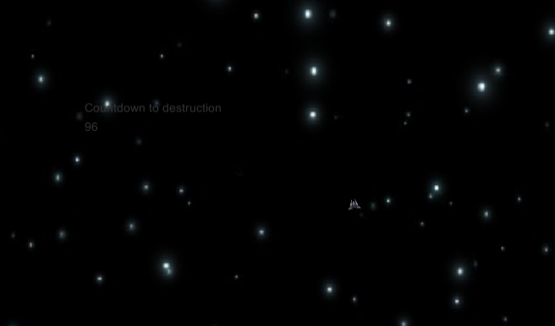

# user interface

* What does the interface need to tell the player?
* Does it pretend to exist in the game world (immersion) or is it a static user interface? (see link)
* <http://www.gamasutra.com/blogs/AnthonyStonehouse/20140227/211823/User_interface_design_in_video_games.php>
* Description/images of the menus
* (Game flow chart)

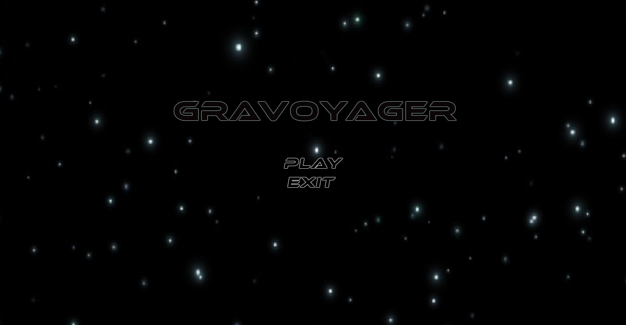

# sound design

* How does the sound design complement the gameplay?
* Does it add to the immersion?
* Does it help the player?

## Music

## Ambience

## Sound effects

# team information

* Team name
* Team members
* roles